

International School

Capstone Project 2
CMU-SE 451

PROJECT PROPOSAL
Version 1.3
Date: May 11, 2026

SEIMS - Smart Expiry Product Integration & Management System

Created by C2SE.15
Nguyen Huy Hoang Bao - 28219004148
Nguyen Pham Nhat Huy - 28211100686
Pham Minh Trang - 28204632177
Duong Quoc Binh - 28219006390
Nguyen Huu Thang – 28211102537

Project Proposal Review Panel Representative:

Name Signature Date
Capstone Project 2 - Mentor:

Name MSc.Truong Dinh Huy Signature Date

PROJECT INFORMATION

Project acronym | SEIMS
Project Title | Smart Expiry Product Integration & Management System
Start Date | March 6, 2026 | End Date |  | May 11, 2026
Lead Institution | International School, Duy Tan University
Project Mentor | MSc.Truong Dinh Huy  Email: huy.truongdinh@gmail.com  Tel: 0982132352
Scrum master / Project Leader & contact details | Pham Minh Trang  Email: pmtrang04@gmail.com  Tel: 0911855450
Partner Organization | Duy Tan University
Team members | Name |  | Email |  | Tel
28219004148 | Nguyen Huy Hoang Bao |  | bao91ndu1819@gmail.com |  | 0385092839
28211100686 | Nguyen Pham Nhat Huy |  | huy785619@gmail.com |  | 0395546300
28204632177 | Pham Minh Trang |  | pmtrang04@gmail.com |  | 0911855450
28219006390 | Duong Quoc Binh |  | duongquocbinh@dtu.edu.vn |  | 0932033856
28211102537 | Nguyen Huu Thang |  | nguyenhuuthang11@dtu.edu.vn |  | 0702377702

DOCUMENT APPROVALS
The following signatures are required for approval of this document.
MSc.Truong Dinh Huy  Mentor | Signature | Date
Nguyen Huy Hoang Bao  Student ID: 28219004148  Team Member | Signature | Date
Nguyen Pham Nhat Huy  Student ID: 28211100686  Team Member | Signature | Date
Pham Minh Trang  Student ID: 28204632177  Project Leader | Signature | Date
Duong Quoc Binh  Student ID: 28219006390  Team Member | Signature | Date
Nguyen Huu Thang  Student ID: 28211102537  Team Member | Signature | Date

REVISION HISTORY
Version | Date | Comments | Author | Approval
1.0 | March 6, 2026 | Create Document | All members
1.1 | March 27, 2026 | Update Document | Huy
1.2 | April 17, 2026 | Update Document | Huy
1.3 | May 11, 2026 | Official Document | Huy

Table of Contents
1. Project Title 1
2. Team Members 1
3. Supervisor(s) 1
4. Problem Statement 2
5. Survey / Existing Solutions 3
6. Objectives and Scope 3
6.1. Objectives (SMART) 3
6.2. Deliverable 5
6.3. System Scope 6
7. Key Features & Requirements 7
7.1. Key Features 7
7.2. Functional Requirements (FR) 7
7.3. Non-Functional Requirements (NFR) 10
8. Constraints and Assumptions 10
8.1. Constraints 10
8.2. Assumptions 11
9. Target Users / Stakeholders 11
10. Technology Stack 11
11. Methodology & Development Plan 12
11.1. Methodology 12
11.2. Development Plan 13
12. System Architecture Overview 14
12.1 System context diagram 14
12.2 System context diagram description 15
13. Potential Risks and Mitigation Strategies 16
14. Expected Outcomes/ Deliverables 17
15. References 18

1. Project Title
SEIMS - Smart Expiry Product Integration & Management System.

2. Team Members
Table 1. Team members information
No. | Name | Email | Role
1 | Nguyen Huy Hoang Bao  Student ID: 28219004148 | bao91ndu1819@gmail.com | Frontend Developer, Backend Developer, Tester,
2 | Nguyen Pham Nhat Huy  Student ID: 28211100686 | huy785619@gmail.com | Product Owner,  Frontend Developer , Backend Developer
3 | Pham Minh Trang  Student ID: 28204632177 | pmtrang04@gmail.com | Scrum Master, Frontend Developer, Backend Developer
4 | Duong Quoc Binh  Student ID: 28219006390 | duongquocbinh@dtu.edu.vn | Frontend Developer, Backend Developer, Tester
5 | Nguyen Huu Thang  Student ID: 28211102537 | nguyenhuuthang11@dtu.edu.vn | Frontend Developer, Backend Developer , Tester

3. Supervisor(s)
Table 2. Mentor information
Full name: | MSc. Truong Dinh Huy
Faculty: | International School - CMU
Tel: | 0982132352
Email: | huy.truongdinh@gmail.com

4. Problem Statement
Retail businesses, especially supermarket chains, frequently face challenges in managing near-expiry products effectively. Due to large-volume inventory operations, uneven sales across branches, and fragmented data stored in different systems such as POS platforms, spreadsheets, or manual records, products approaching expiration are often difficult to monitor and handle in a timely manner. As a result, businesses may experience increased product waste, disposal costs, revenue loss from unsold inventory, and potential risks associated with expired goods.
In many supermarkets, the handling of near-expiry products is still largely manual and inconsistent. Discount decisions are often applied ad hoc without standardized rules, while donation activities for usable products close to expiration are not systematically managed. In addition, inventory imbalances among branches may lead to some stores facing overstock and waste, while others may have shortages, yet there is often no centralized mechanism to support redistribution or coordinated handling.
From the customer perspective, consumers may be unaware of discounted near-expiry products available at nearby stores, limiting opportunities to access quality goods at reduced prices. At the same time, charitable organizations may have difficulty identifying and receiving suitable products for donation through a structured and transparent process.
Existing retail systems typically focus on conventional inventory and sales management but provide limited support for proactive expiry monitoring, automated discount strategies, donation coordination, and integrated visibility of near-expiry products. This creates a gap for a specialized platform that not only helps businesses reduce waste and recover value from near-expiry inventory, but also supports social impact through redistribution.
To address these challenges, this project proposes the development of SEIMS (Smart Expiry Product Integration & Management System), a web-based centralized platform for managing and integrating near-expiry products across supermarket chains. The system enables supermarkets to manage inventory by batch and expiration date, and automatically detect near-expiry products based on configurable threshold values.
In addition, the system supports a hybrid operational model: B2C, where customers can browse and purchase discounted near-expiry products through a marketplace with pickup or delivery support; and B2B, where suitable products can be redistributed to charitable organizations through a donation management workflow. The platform also provides dashboards and reporting tools to support operational monitoring and decision-making.
Through this solution, supermarkets can improve near-expiry product handling efficiency, reduce waste, recover revenue, enhance customer access to discounted goods, and contribute to broader social sustainability goals.

5. Survey / Existing Solutions
Table 3. Survey of Existing Promotion & Retail Integration Platforms
Criteria | Too Good To Go | Flashfood | Olio | Seims
Near-Expiry Product Discounting | ✓ | ✓ | Partial | ✓
Inventory & Expiry Management | ✗ | Partial | ✗ | ✓
Multi-Store / Multi-Supermarket Support | ✗ | Partial | ✗ | ✓
Customer Marketplace (B2C) | ✓ | ✓ | Partial | ✓

6. Objectives and Scope

6.1. Objectives (SMART)
Objective 1: Develop a Centralized Near-Expiry Product Integration Engine
- Measurable Goal:
- Build a system capable of integrating product data from multiple sources, including legacy POS systems via API and manual uploads (Excel/CSV), ensuring data consistency.
- Success Criteria:
- Successfully integrate at least 2 different data formats (API and Excel).
- Achieve a data synchronization error rate of < 1%.
- Maintain a unified product catalog across different supermarket branches.
Objective 2: Implement an Automated Expiry Tracking and Dynamic Pricing Rule Engine
- Measurable Goal:
- Develop a logic-based engine to classify inventory into different status levels (Safe, Warning, Near-Expiry, Expired) and automatically suggest discount rates.
- Success Criteria:
- 100% of imported inventory lots are automatically assigned an expiry-based status.
- The system generates real-time price updates based on pre-configured discount rules (e.g., 50% off if 3 days remaining).
Objective 3: Build an Operational Analytics Dashboard for Inventory Management
- Measurable Goal:
- Develop an interactive dashboard that visualizes near-expiry trends, loss prevention metrics, and inventory distribution in real time.
- Success Criteria:
- Provide real-time visualization (bar charts, pie charts) of waste risk by category and store.
- Allow filtering by store branch, product category, and expiry date range.
- Increase decision-making efficiency for stock clearance by 30%.
Objective 4: Develop an Operational Monitoring and Tracking System
- Measurable Goal:
- Develop dashboard and monitoring features to help supermarket staff track near-expiry products and operational status efficiently.
- Success Criteria:
- Near-expiry products are automatically highlighted and displayed on the monitoring dashboard.
- Provide operational visibility for staff to handle near-expiry inventory efficiently.
Objective 5: Ensure a Secure, Scalable, and Role-Based Management System
- Measurable Goal:
- Implement Authentication and Role-Based Access Control (RBAC) for Admin, Supermarket Admin, Store Staff, Customer, Charity Organization, and Delivery Partner.
- Success Criteria:
- Secure login with JWT/HTTPS and encrypted sensitive data.
- Strict separation of duties: Staff can perform inventory checks, but only Managers can approve discount policies.
- Optimized system performance capable of handling up to 10,000 product SKUs without latency.

6.2. Deliverable
Deliverable 1: Functional Web-Based Near-Expiry Management Platform A fully operational web application comprising the following core modules:
- User & RBAC Module: Authentication and role-based access control for Admin, Supermarket Admin, Store Staff, Delivery Partner, Charity Organization, Customer.
- Integration & Sync Module: Tools for Excel/CSV imports and RESTful API endpoints for external POS data.
- Inventory Lot Management Module: Tracking inventory by "Lot/Batch" including quantity, location, and expiry date.
- Dynamic Pricing Rule Engine: A configuration interface for setting and applying automated discount policies.
- Analytics Dashboard: Visual interface for waste management and sales performance tracking.
Deliverable 2: Technical Documentation A comprehensive set of documents including:
- System Architecture Design: Overview of the tech stack (ReactJS, FastAPI, MySQL) and data flow diagrams.
- Database Schema (ERD): Relational design focusing on Inventory Lots, Discount Rules, and Store hierarchies.
- API Specification: Swagger/OpenAPI documentation for all backend services.
- Rule Engine Logic & Algorithms: Detailed explanation of the automated pricing and status classification logic.
- Security & Deployment Guide: Instructions for Docker-based deployment, SSL configuration, and JWT implementation.
Deliverable 3: Project Report and Final Presentation
- Project Report: A formal document covering problem analysis (food waste/loss prevention), methodology, implementation details, testing results (Unit, Integration, UAT), and future scalability.
- Final Presentation: A set of slides and a demo video showcasing the end-to-end workflow from data import to discount application.

6.3. System Scope
- Stakeholders:
- Admin, Supermarket Admin, Store Staff, Customer, Charity Organization, Delivery Partner, Project Development Team.
- Main Features:
- Supermarket registration and approval management.
- Multi-tenant governance for managing supermarkets, stores, and staff accounts.
- Inventory lot management with expiry date tracking.
- Automated near-expiry detection based on configurable threshold values.
- Automatic discount calculation using pricing rules.
- Donation management module (B2B) for charity organizations.
- Near-expiry marketplace for customers (B2C).
- Order processing and pickup management.
- Delivery status coordination.
- Dashboard and analytics for monitoring near-expiry products, donations, and sales recovery.
- Out of Scope:
- The system does not manage full supermarket ERP operations such as supplier procurement or full financial accounting.
- The system does not handle real-time POS integration with physical checkout systems (demo-level integration only).
- The system does not manage warehouse logistics optimization or transportation routing algorithms.
- The system does not guarantee elimination of product waste beyond configured near-expiry handling rules.

7. Key Features & Requirements

7.1. Key Features
- User Authentication and Role-Based Access Control
- Multi-Supermarket and Store Management
- Inventory Lot Lifecycle Management
- Near-Expiry Detection and Monitoring
- Discount Management
- Donation Management
- Marketplace and Order Management
- Dashboard and Analytics Reporting

7.2. Functional Requirements (FR)
Table 4. Functional Requirements
ID | Functional Requirement | Description
FR01 | Sign Up | Users can create an account using email and password.
FR02 | Log In | Users can log in using their registered email and password.
FR03 | Log Out | Users can log out to ensure account security.
FR04 | Forgot Password | Users can reset their password via email.
FR05 | Lock/Unlock User Account | Admin can lock or unlock user accounts when necessary.
FR06 | Manage Profile | Users can view and edit their personal profile; Admin can manage user profiles.
FR07 | Store Management | The system shall allow Supermarket Admin to create, update, and manage stores
FR08 | Staff Management | The system shall allow Supermarket Admin to create and manage store staff accounts.
FR09 | Policy Configuration | The system shall allow Supermarket Admin to configure near-expiry thresholds and discount policies.
FR10 | Coupon Management | The system shall allow Supermarket Admin to create, update, disable, and manage promotional coupon codes for customer orders.
FR11 | Create Inventory Lot | The system shall allow store staff to create inventory lots including lot code, expiry date, and quantity.
FR12 | Validate Expiry Date | The system shall validate that expiry date must be later than the current date.
FR13 | Calculate Remaining Days | The system shall calculate remaining days for each inventory lot.
FR14 | Update Lot Lifecycle Status | The system shall update inventory lot status (New, Near-Expiry, Discounted, Donated, Sold, Expired).
FR15 | Prevent Expired Sale | The system shall prevent customers from purchasing expired products.
FR16 | Detect Near-Expiry Products | The system shall automatically detect near-expiry products based on configured threshold values.
FR17 | Apply Discount Policy | The system shall automatically calculate discounted prices for near-expiry products.
FR18 | Override Discount | The system shall allow Supermarket Admin to manually override discount prices.
FR19 | Create Donation Offer | The system shall allow store staff to create donation offers from near-expiry inventory lots.
FR20 | View Donation Offers | The system shall allow charity organizations to view available donation offers.
FR21 | Submit Donation Request | The system shall allow charity organizations to request donation offers.
FR22 | Approve Donation Request | The system shall allow store staff to approve or reject donation requests.
FR23 | Browse Near-Expiry Products | The system shall allow customers to browse near-expiry products by store and category.
FR24 | Search and Filter Products | The system shall allow customers to search and filter products by store, category, discount rate, or expiry date.
FR25 | Place Order | The system shall allow customers to place orders.
FR26 | Online Payment Integration | The system shall allow customers to make online payments through the VNPAY payment gateway and verify payment results before confirming orders.
FR27 | Order Management | The system shall allow store staff to process and update order status.
FR28 | View Order History | The system shall allow customers to view their past order history.
FR29 | Update Delivery Status | The system shall allow delivery partners to update shipment or pickup status.
FR30 | View Dashboard | The system shall provide dashboards displaying near-expiry statistics, donation metrics, and sales recovery performance.
FR31 | Audit log(Supermarket Admin) | The system shall record and allow Supermarket Admin to view all system activities including user actions, inventory changes, pricing updates, orders, donations, and configuration changes.
FR32 | Reports and analysis | The system shall generate reports and analytics on inventory, near-expiry products, discounts, sales recovery, and donations, and allow export in standard formats.

7.3. Non-Functional Requirements (NFR)
Table 5. Non-Functional Requirements
ID | Category | Requirement Description
NFR01 | Performance | The system shall respond to user requests within 5 seconds under normal operating conditions.
NFR02 | Availability | The system shall maintain at least 99% uptime, excluding scheduled maintenance periods.
NFR03 | Security | All user authentication data shall be encrypted, and the system shall use HTTPS for all communications.
NFR04 | Data Isolation | The system shall ensure strict data separation so that each supermarket can only access its own data.
NFR05 | Data Integrity | The system shall prevent duplicate, inconsistent, or corrupted records during inventory updates, order processing, or donation transactions.
NFR06 | Reliability | The Near-Expiry Detection Engine and background jobs shall execute according to the configured schedule without data loss.
NFR07 | Maintainability | The system shall adopt a modular architecture (Frontend, Backend API, Database, Cache, Scheduler) to allow easy maintenance and future enhancements.
NFR08 | Compatibility | The system shall be compatible with major web browsers (Chrome, Edge, Safari, Firefox) and responsive across desktop and mobile devices.

8. Constraints and Assumptions

8.1. Constraints
Table 6. Constraints
ID | Constraint Category | Description
C01 | Time | The Capstone project must be completed within one semester.
C02 | Tools | The system is developed using available computing resources and standard web technologies without high-performance infrastructure.
C03 | Platform | The system is deployed and tested primarily on web platforms.
C04 | Data | The system uses manually entered or imported sample data for demonstration purposes.

8.2. Assumptions
- Product inventory data (lot number, expiration date, quantity) are accurately entered into the system by Store Staff.
- Each supermarket defines clear near-expiry and discount policies used by the system for automatic processing.
- Imported data (Excel/CSV) are correctly formatted and validated before being processed.

9. Target Users / Stakeholders
User Roles
- Admin: Responsible for managing the overall platform, including supermarket management, charity organization management, delivery partner management, customer management, and overall system monitoring.
- Supermarket Admin: Manages a specific supermarket chain, configures near-expiry and discount policies, manages stores and store staff, and monitors performance across the chain.
- Store Staff: Handles store-level operations including inventory lot entry, near-expiry product handling, donation processing, and customer order fulfillment.
- Customer: Browses and purchases near-expiry products through the marketplace and tracks order status.
- Charity Organization: Manages donation requests, views donation offers, and confirms receipt of donated products.
- Delivery Partner: Updates delivery status and confirms completion of assigned deliveries.

10. Technology Stack
- Frontend: ReactJS (Web)
- Backend: FastAPI
- Language: Python
- Web Framework: FastAPI
- ASGI Server: Uvicorn
- Environment: Virtual Environment (myvenv)
- Database: MySQL
- Support & Management Tools:
- Version Control: GitHub
- Project Management: Jira
- IDE/Editor: IntelliJ IDEA, Visual Studio Code
- Browsers for testing: Google Chrome, Microsoft Edge, Cốc Cốc
- Team Management: Zalo, GG Drive, GG Meet

11. Methodology & Development Plan

11.1. Methodology
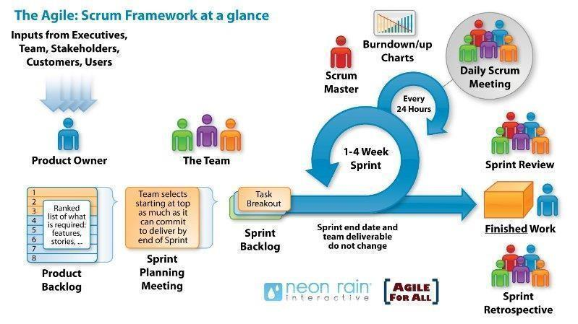
Figure 1. Scrum process
- Scrum is an iterative and incremental agile software development framework for managing software projects and product or application development.
- Scrum focuses on project management institutions that are difficult to plan
- Mechanisms of empirical process control, where feedback loops that constitute the core management technique are used as opposed to traditional command-and-control management.
- Its approach to planning and managing projects is to bring decision-making authority to the level of operation properties and certainties.
Why did we choose the Scrum process to develop the system?
- Choose Scrum for its flexibility and iterative nature.
- Easily adapts to changing needs and new features.
- Continuous improvement through sprint feedback.
- Early issue detection and resolution.
- Reduces risks from inexperience and changing requirements

11.2. Development Plan
Table 7. Development Plan
No. | Task Name | Start | Finish
1 | Initial | 02/02/2026 | 08/02/2026
1.1 | Requirements Gathering and Scope Definition | 02/02/2026 | 08/02/2026
2 | Development | 06/03/2026 | 07/05/2026
2.1 | Sprint 1 | 06/03/2026 | 26/03/2026
2.2 | Sprint 2 | 27/03/2026 | 16/04/2026
2.3 | Sprint 3 | 17/04/2026 | 07/05/2026
3 | Release | 08/05/2026 | 11/05/2026

12. System Architecture Overview

12.1 System context diagram

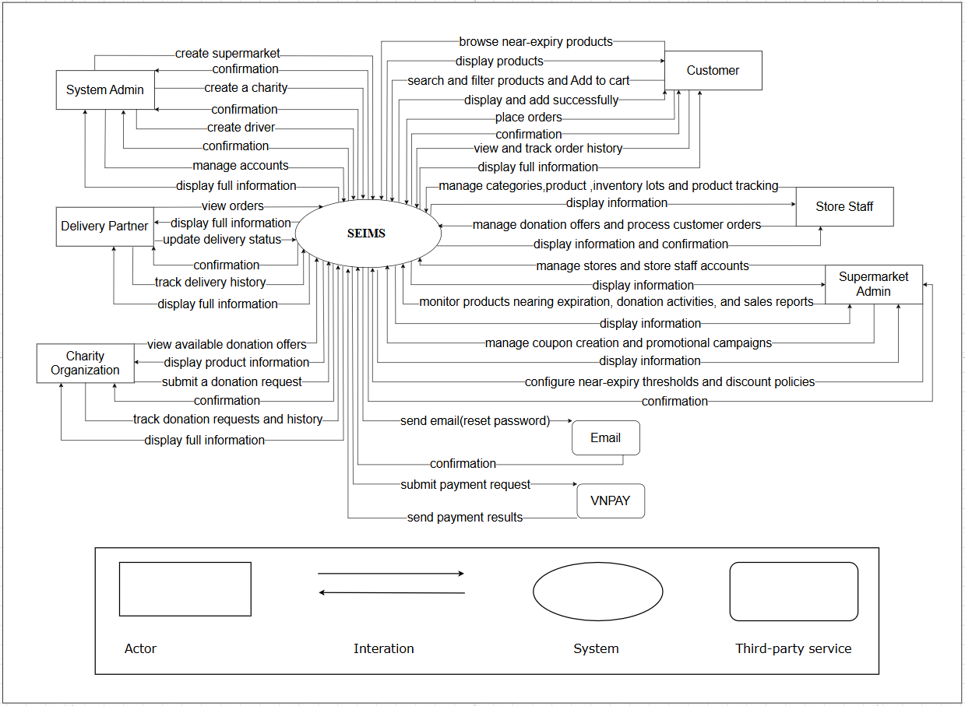
Figure 2. Context diagram

12.2 System context diagram description
- Admin:
- Manage supermarket administrator accounts
- Manage charity organization accounts
- Manage delivery partner accounts
- Supermarket Admin:
- Manage stores and store staff accounts
- Configure near-expiry thresholds and discount policies
- Monitor products nearing expiration, donation activities, and sales reports
- Manage coupon creation and promotional campaigns
- Store Staff:
- Manage product categories
- Manage product information
- Manage inventory lots and expiry information
- Monitor near-expiry products
- Create and manage donation offers
- Process and update customer orders
- Customer:
- Browse near-expiry products
- Search and filter products and Add to cart
- Place orders
- View and track order history
- Charity Organization:
- View available donation offers
- Submit donation requests
- Track donation request status
- View donation request history
- Delivery Partner:
- View delivery details
- Update delivery status
- Track delivery history
- Email Service (External System):
- SEIMS sends email requests
- Email Service returns confirmation responses
- VNPAY Payment Gateway (External System):
- SEIMS submits payment requests
- VNPAY returns payment results

13. Potential Risks and Mitigation Strategies
Table 8. Risk
Risk Category | Specific Risk | Likelihood | Impact | Mitigation Strategy
Technical | Incorrect inventory lot entry (wrong expiry date or quantity) | Medium | High | Implement unit testing for expiry calculation logic, validate date formats strictly, and test edge cases (leap year, timezone).
 | System performance issues when processing large inventory datasets | Medium | Medium | Optimize database indexing, use pagination, and apply caching (Redis).
Security | Unauthorized access across supermarkets (multi-tenant data leakage) | Low | High | Enforce strict RBAC and isolate data by Supermarket ID.
Operational | Store Staff delay in handling near-expiry products | Medium | High | Implement dashboard monitoring and operational tracking for overdue handling.
Legal | Accidental listing of expired products | Low | High | Prevent expired lots from being published through automatic validation rules.
Data | Inaccurate imported Excel/CSV data | Medium | Medium | Validate file format and provide preview before confirmation.
Schedule | Delay in implementing rule engine or donation workflow | Medium | Medium | Prioritize core modules early and apply sprint-based development planning.
Resource | Limited real supermarket data for testing | High | Medium | Use simulated multi-supermarket datasets for system testing.

14. Expected Outcomes/ Deliverables
Table 9. Project Deliverables and Descriptions
Deliverable | Description
Application | A fully functional web-based Near-Expiry Product Management Platform supporting multi-supermarket management, inventory lot tracking, near-expiry detection, discount management, donation workflow (B2B), and marketplace functionality (B2C).
Source Code | Complete source code of the web application (Frontend: React, Backend: FastAPI, Database: MySQL), properly structured and version-controlled for future maintenance and expansion.
Technical Documentation | Proposal, Project Plan, System Architecture Design, Database Design (ERD), API Documentation (Swagger), User Interface Design, Test Plan.
Demo Video | A recorded demonstration showcasing key workflows: inventory lot entry → near-expiry detection → discount handling → donation process → customer order placement → order completion.
Final Report | A formal project report summarizing objectives, methodology (Scrum), system design, implementation details, testing results, challenges, limitations, and future improvements.

15. References
No. | References | Document Information
1 | Scrum Model | https://en.wikipedia.org/wiki/Scrum_(software_development)
 |  | https://www.atlassian.com/agile/scrum
 |  | https://www.digite.com/agile/scrum-methodology/
 |  | https://www.scrum.org/resources/scrum-guide
2 | Technical | https://www.flutterclutter.dev/flutter/tutorials/implementingedge-detection-in-flutter/2020/1509/
 |  | https://stackoverflow.com/questions/14248571/findingproperties-of-sloppy-hand-drawn-rectangles
 |  | https://www.tutorialspoint.com/how-to-detect-a-rectangle-andsquare-in-an-image-using-opencv-python
 |  | https://platform.openai.com/docs/overview
 |  | https://www.mysql.com/docs/
3 | Standard | https://www.nws.noaa.gov/oh/hrl/developers_docs/General_So ftware_Standards.pdf
 |  | https://standards.ieee.org/standard/12208-2017.html
 |  | https://en.wikipedia.org/wiki/Scrum_(software_development)
Table 10. References

